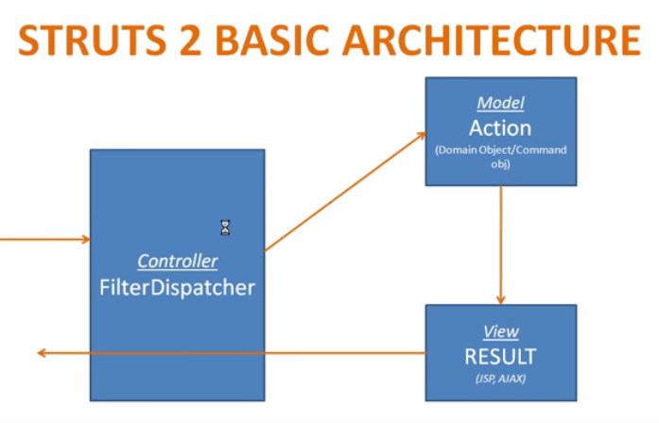

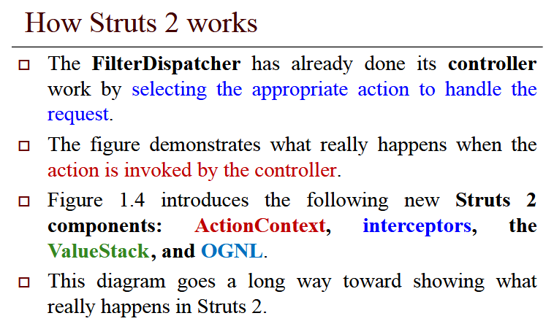

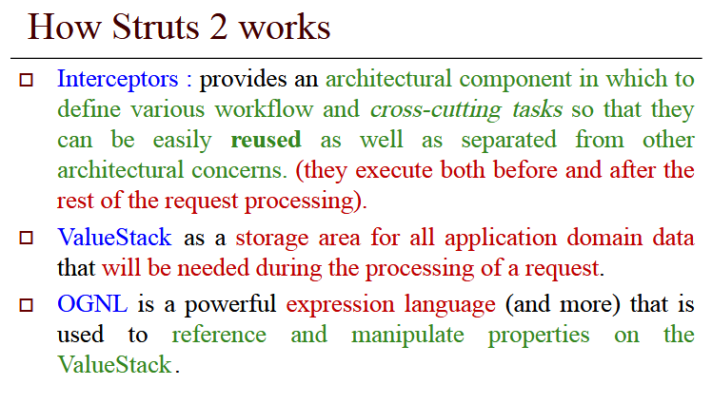**OGNL** is the expression language where **OGNL** stands for Object-Graph Navigation Language. **OGNL** is used to store form parameters as java bean variables in ValueStack and to retrieve the values from ValueStack in result pages.